**What is DNS?**

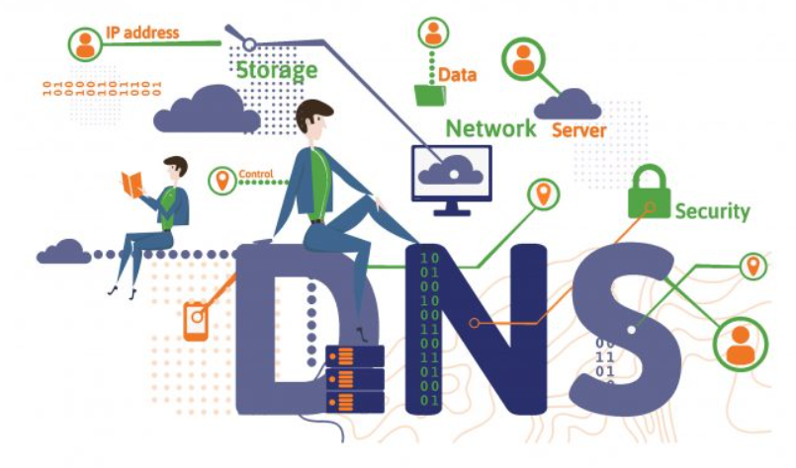

The Domain Name System (DNS) is the phonebook of the Internet. Humans access information online through domain names, like nytimes.com or espn.com. Web browsers interact through Internet Protocol (IP) addresses. DNS translates domain names to [IP addresses](https://www.cloudflare.com/learning/dns/glossary/what-is-my-ip-address/) so browsers can load Internet resources.

Each device connected to the Internet has a unique IP address which other machines use to find the device. DNS servers eliminate the need for humans to memorize IP addresses such as 192.168.1.1 (in IPv4), or more complex newer alphanumeric IP addresses such as 2400:cb00:2048:1::c629:d7a2 (in IPv6).

It might seem like magic when you go online shopping, video chat across continents, and stream videos or music to your phone, but this is all thanks to the sophisticated engineering achievement that is the domain name system (DNS). DNS is a powerful network that keeps billions of internet users and over 300 million domain names connected.

The DNS underpins the internet we use every day. This transparent network runs in the background whenever you send an email, or load a website. DNS is often likened to the internet’s version of a telephone book. To call someone, you must first find their telephone number. To do so you look up a contact name, similary, DNS converts email addresses and websites humans read into computer-readable, numerical IP addresses.

DNS is a complicated topic with many aspects that affect your day to day life, especially if you own a website. If you’re a domain owner, listen up, because the DNS controls different aspects of your domain name. If you simply want to broaden your knowledge of what’s going on behind the scenes of the world wide web in general, stay with us.

In this article, we will discuss the ins and outs of the domain name system, including the basics of how it works, why it exists and how the DNS relates to your domain name.

The DNS goes by many names, including name server, domain name system server, and nameserver. Regardless of which name is used, all describe the process of making domain names alphabetical. DNS also refers to the hierarchical system used to search through the network of millions of IP addresses, to locate the exact IP of your desired website.

How DNS Works?

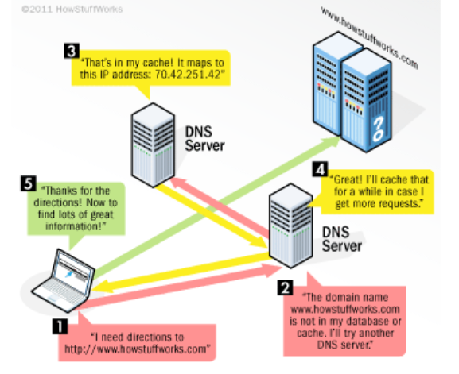

Everything that connects to the internet - websites, tablets, laptops, mobile phones, Google Home, internet thermostats, and refrigerators has an IP address. An internet protocol address by its full name is a unique string of numbers that identifies each digital device to communicate via the world wide web.

Thanks to DNS, there is no need to maintain an address book of IP addresses. Every time you use a domain name, the DNS service locates the website and translates the name into its corresponding IP address. Alphabetic domain names are easier to remember than IP address numbers, so when you type [www.google.com](http://www.google.com/) into a web browser, you only have to remember the URL.

1. IP addresses help locate a computer on the internet and relay the information (website data, emails etc) traveling between computers. As soon as you type a domain name, for example, Amazon.com into your browser, your browser, and computer check if one of them has the domains related IP address in their memory.
2. If Amazon.com isn’t in your computer's local memory (cached memory), it expands the search out to the internet where it queries the DNS to determine if the domain exists in their DNS database. If the first DNS doesn’t find it on its server, it sends it to the next server until the right domain name server is found. For example, the URL for Amazon.com is associated with servers run by Amazon Web Services. The domain name system allows you to reach Amazon’s servers when you type Amazon.com into your web browser.
3. Once the DNS server finds the domain name Amazon.com, the server returns the domain name, and it’s IPS address to the requesting DNS server, along down the line until it arrives back at your computer.
4. Once the IP address has reached your computer, your browser finds it on the internet. Next up, it communicate with the domain name hosted to request any associated files. The host server returns the files which display Amazon.com in your web browser.

DNS Operations

The DNS operates a client/ server network system performing the following operations:

1. Send requests to and receives responses from DNS servers. Each request contains a name which results in the corresponding IP address returned from the server. This is known as forward DNS lookups.
2. Besides forward lookups, the DNS can request reverse lookups that query an IP to determine the associated domain name.
3. Find the correct servers to deliver email.

How is the DNS Organized?

The internet is set up of a large network of computers located around the world. These networks connect underground and in some cases under the sea. DNS is a hierarchical system that works by crawling through information on a system of linked DNS servers to determine the location of a particular domain names server.

When people visit your domain name, its DNS settings determine which servers it reaches. For example, if you use Amazon's DNS settings, your visitors will reach the Amazon servers hosting your website. If you change the DNS settings to another company's DNS servers, visitors will reach them.

To understand how the hierarchy is queried by your computer to produce a website on your screen, you need a basic understanding of the elements that comprise a domain name and how these relate to IP addresses.

* **Third-Level Domain** - Also known as the subdomain. Simply put, a subdomain is anything that appears before the second level domain, the most common subdomain is www. But they can take many forms, such as *books.google.com*.
* **Second-Level Domain** - This is the often the name of the website and the unique part of the domain name, appearing to the immediate left of the TLD. For example, the second-level domain in the URL [www.amazon.com](http://www.amazon.com) is *Amazon* sandwiched between the third and top-level domain.
* **Top-Level Domain** - Is the furthest point to the right of the domain. The most common TLD is .com. Within the hierarchy, TLDs are at the top with regard to domain names. ICANN oversees TLDs and facilitates the distribution of TLDs, most commonly through a domain registrar.
* **IP Address** - An Internet Protocol address is an addressable location on the internet. Each IP is unique with its network. In relation to websites, the network is the entire internet. The most common form of IP addresses are known as is IPv4, and written as a set of four numbers; each set has no more than three digits between 0 and 255, and each set is separated by a single dot. **157.158.458.756**, for example, would be a valid IPv4 address. The DNS maps a name to that address saving you the bother of remembering a complicated series of numbers for each website you want to visit.

DNS Configuration

Most sites have a server which takes care of its DNS. In most cases, two DNS servers are configured on your router and/ your computer to connect your ISP via DHCP. You may configure two in the case the primary server fails. If there was a problem connecting to the primary server, your computer will automatically switch to the secondary server.

A DNS lookup is normally a super-fast process with a split second turnaround to query, locate and deliver a website. Once the lookup is complete, the client computer is connected to the destination server freeing the DNS server up to deal with its next request.

It’s most likely your domain is using your ISP’s default DNS servers. However, you don’t have to. There are plenty of third-party DNS servers which may provide you with faster DNS resolves. Speed is an essential part of SEO since the time to connect to a web page is a ranking factor for Google.

Domain Name Elements

You may redirect your DNS using the different record types which make up a domain. Which to use depends on the information you’re trying to enter. You can set up **A, AAAA, CNAME, SRV, NS, TXT, MX, MXE, URL** redirect records.

* An **A Record** directs your domain name to an individual server through its IP address. Each domain name has a primary A record, the information held within the A record controls what your domain name does when someone visits your website. An A record (Address record) allows you to associate a domain name or subdomain with an IP address (32-bit).
* An **AAAA** record works in a similar way to an A record except it lets you direct your domain to a 128-bit Ipv6 address.
* The **CNAME** is used to redirect your domain or subdomain to the IP address of the destination hostname. This record identifies a domain name as an alias of another name. The benefit being, if the IP of the destination hostname changes, you won’t need to update your DNS records because the CNAME will have the same IP.
* An **MX Record** is used to direct mail to the appropriate mail server. MX records must point to a host name and never directly to an IP address.
* The **NS Record** lets you delegate a subdomain to a nameserver associated with the domain. This is helpful if your subdomain is hosted separately from the domain name.